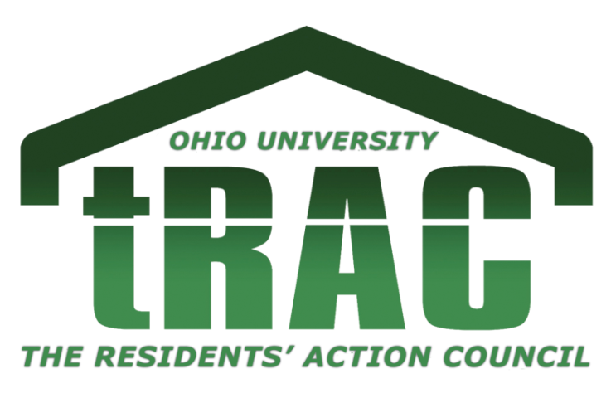
tRAC CO-SPONSORSHIP PACKET

(updated 11-5-19)

Purpose – p. 1

Steps to Apply For tRAC Co-Sponsorship – p. 2

Co-Sponsorship Guidelines and What tRAC Will Not Sponsor – p. 3

Co-Sponsorship Request Procedures – p. 4

Purpose

tRAC is pleased to announce that we are looking to co-sponsor and collaborate with other student organizations this Spring Semester. tRAC is looking to fund programs that can benefit on-campus students, in amounts of up to $500.

We hope to provide monetary assistance as well as personnel assistance, in order to give members of tRAC and other students who live on-campus an opportunity to help plan programs outside of their hall councils.
Steps to Apply For tRAC Co-Sponsorship!

- Before submitting a co-sponsorship application, please make sure you meet the following requirements:
  - Your event occurs at least 3 weeks after the date of your submission.
  - Your event is open to all students
  - Review "What tRAC Will Not Sponsor" and all other guidelines, located in this packet.

- Also refer to Co-Sponsorship Guidelines and What tRAC Will Not Sponsor (p.3). Requests cannot exceed $500.

- Please fill out the form by Wednesday at 5:00 P.M. and submit to programming@ohiotrac.com in order to have your request considered for the subsequent Monday General Body meeting. CO-SPONSORSHIP REQUESTS WILL NOT BE CONSIDERED IF PAPERWORK IS NOT FILLED OUT COMPLETELY AND PROPERLY.

- If your request is chosen by the tRAC executive board, you will be invited to present at a General Body meeting, which are on Mondays at 7:00 P.M. in LLC 102/104.
- General Body will vote on your request. Refer to Co-Sponsorship Request Procedures (p.4). You will also receive contact information for General Body members who want to be involved in the planning of the program.
- Hold your program. Communicate with the VP for Programming (programming@ohiotrac.com) in order to make purchases for the event. All advertisements MUST contain the tRAC logo.

Co-Sponsorship Guidelines

- All requests must be open to all on-campus students.

- Funding shall support social, cultural, educational and recreational programming for on campus students, as well as opportunities to serve the surrounding community.

- All requests are limited to a total amount of $500.00.

- No alcohol may be permitted or tolerated at any program sponsored by tRAC. In addition, all other rules of the Ohio University Student Code of Conduct must be followed.
What tRAC Will Not Sponsor

- Alcohol
- Candles, incense, or oil lamps
- Cash prizes
- Controlled substances
- Donations
- Food for consumption without an EHS permit (when required)
- Gasoline for personal vehicles
- Lodging
- Long term rentals
- Purchase or rental of live animals
- Radioactive/explosive materials
- Travel expenses for trips of an excessive distance from campus
- Weapons or ammunition
- Programs posthumously
- Any other item in violation of Ohio University policy or the law at the discretion of the tRAC executive board

Procedures For Co-Sponsorship Requests

- The funding request must meet all funding guidelines as determined by the Residents’ Action Council, and have a properly filled out funding request form. The VP for Finance will review all funding requests for errors.

- The presenter shall be a representative from the organization that is requesting the funding.

- The person requesting funding shall be allotted a maximum of 5 minutes to present the details of their funding request.

- Immediately following the presentation, the General Body will have the opportunity for a question and answer session.

- After the question and answer session, the presenter will be asked to leave the room, and General Body will proceed to further discussion of the funding request.

- At any time, a general body member may:
  - Move to vote
  - Move to amend request (e.g. change amount of funding, strike a line item)
  - Move to table (this would postpone discussion until the following meeting)

- At the conclusion of the discussion session the VP for Finance will call for a vote, if one has not already been called for.

- The VP for Administrative Affairs and VP for Finance shall be responsible for counting all votes.
  - A simple majority of members with voting rights (50%+1) is required for a request to pass.
  - If a majority is not reached, another motion must be made.

- At the conclusion of the vote, the VP for Finance shall announce the decision.

